Online Food Order System

Krutika Rangari 219091

Nidhi Pakhan 219112

**Abstract**

ONLINE FOOD ORDER SYSTEM is a website designed primarily for use in the food delivery industry. This system will allow hotels and restaurants to increase scope of business by reducing the labor cost involved. The system also allows to quickly and easily manage an online menu which customers can browse and use to place orders with just few clicks. Restaurant employees then use these orders through an easy to navigate graphical interface for efficient processing.

**Introduction**

It is known globally that, in today’s market, it is extremely difficult to start a new small-scale business and live-through the competition from the well-established and settled owners. In fast paced time of today, when everyone is squeezed for time, the majority of people are finicky when it comes to placing a food order. The customers of today are not only attracted because placing an order online is very convenient but also because they have visibility into the items offered, price and extremely simplified navigation for the order.

Online ordering system that we are proposing here, greatly simplifies the ordering process for both the customer and the restaurant. System presents an interactive and up-to-date menu with all available options in an easy to use manner. Customer can choose one or more items to place an order which will land in the Cart. Customer can view all the order details in the cart before checking out. At the end, customer gets order confirmation details. Once the order is placed it is entered in the database and retrieved in pretty much real time. This allows Restaurant Employees to quickly go through the orders as they are received and process all orders efficiently and effectively with minimal delays and confusion.

**Purpose**

* For placing any orders customers have to visit hotels or restaurants to know about food items and then place order and pay. In this method time and manual work is required.
* While placing an order over the phone, customer lacks the physical copy of the menu item, lack of visual confirmation that the order was placed correctly.
* Every restaurant needs certain employees to take the order over phone or in-person, to offer a rich dining experience and process the payment. In today’s market, labor rates are increasing day by day making it difficult to find employees when needed.

Hence, to solve this issue, what we propose is an “Online Food Order System”.

The main advantage of our system is that it greatly simplifies the ordering process for both the customer and the restaurant and also greatly lightens the load on the restaurant’s end, as the entire process of taking orders is automated.

**Program Requirements**

**Product Perspective:**

The Online Food Order System application is a web-based system. It can be accessed using web browser.

**System Model:**

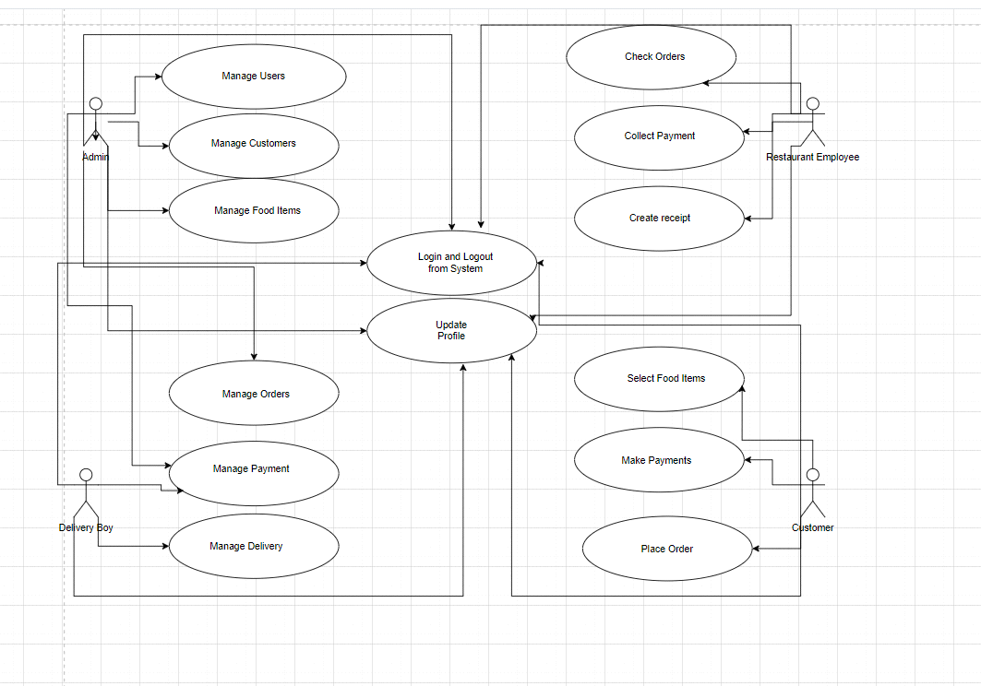

**Customer Activity Diagram:**

This section lists the activity diagram and describes the flow of the activities in the system for customer.

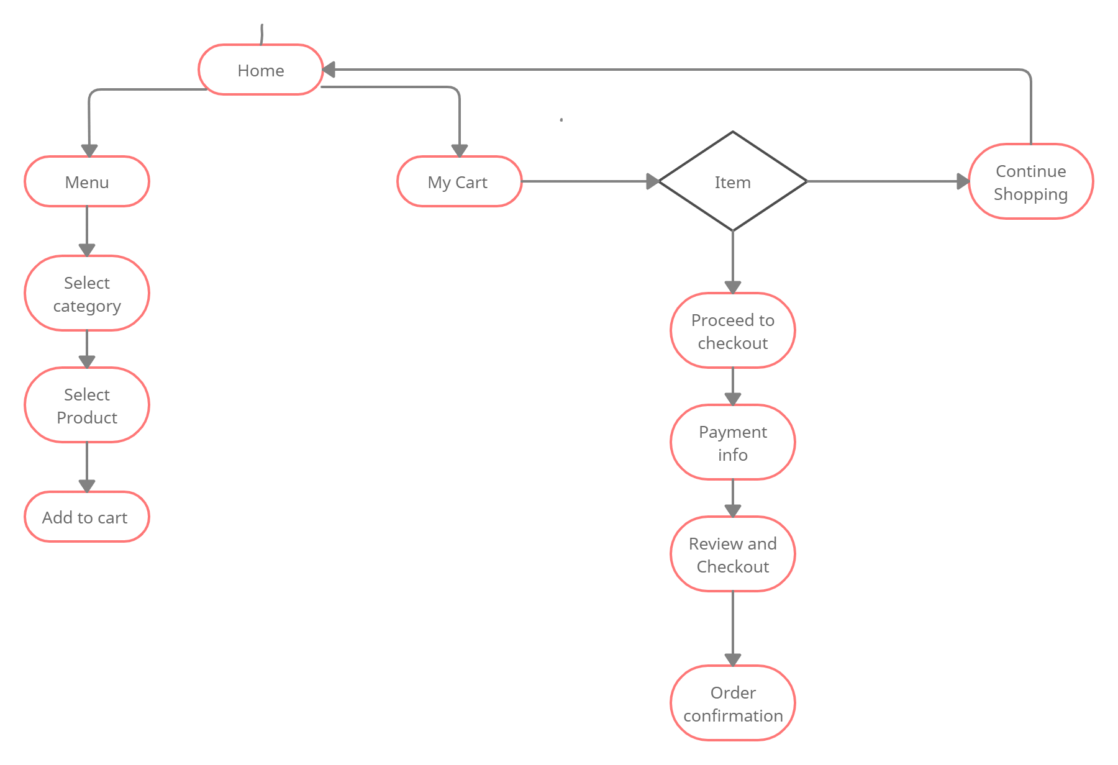

**Customer functionality**

Customers of the Web Ordering system will interact with the application through an easy to use top navigation menu.

* “Home” menu option: allows the users to select an item to place an order.
* “Menu” option: a ‘Drop-Down’ menu, allows users to see all food items per category.
* “My Cart (x)”menu option:
* Allows users to see details of the items placed in cart. Details include Category, Product Name, Product Description, Quantity, Price, Total per item and final Total of the order. It also allows ‘Update’ and ‘Delete’ . User can then use a ‘Proceed to checkout’ button to proceed further.
* Once, Check Out button is selected, user will be prompted for the payment method . Cash on delivery or Card payment.
* User will then be presented with a “Review Order” page, which will display Payment Information along with Order details to review. User can then use a ‘Check Out’ button to place an order.
* Once order is placed, user will be presented with appropriate Order confirmation success/failure message.

**Admin functionality**

* Add, Modify and Delete Category: Allows to add or update and delete food Category name .
* Add, Modify and Delete Product: Allows to add or update and delete Product Name, Description, Price and choose particular Category .
* Manages Restaurant Employee and Delivery Boy : Provides User Id and Password.

**Future Work:**

The following section describes the work that will be implemented with future releases of the software.

* Customize orders: Allow customers to customize food orders
* Enhance User Interface by adding more user interactive features. Provide Deals and promotional Offer details to home page. Provide Recipes of the Week/Day to Home Page
* Payment Options: Add different payment options such as PayPal, Cash, Gift Cards etc. Allow to save payment details for future use.
* Delivery Options: Add delivery option
* Order Tracking: Live tracking of the delivery.

**ER Diagram:**

